**SOFTWARE DESIGN**

**FunixSwap**

**1. Architecture**

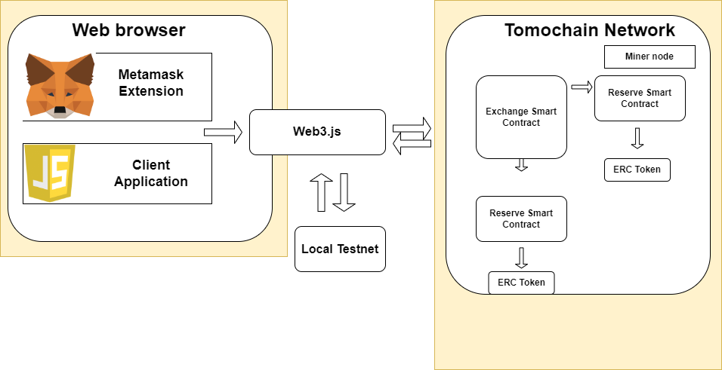

**2. Class Design**

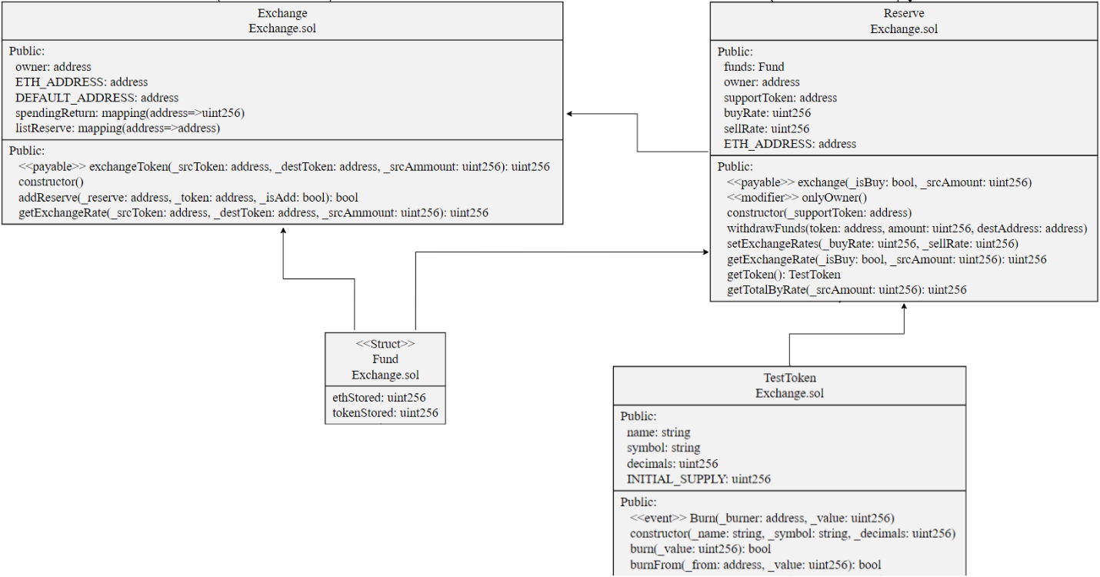

1. **Functional Design**
2. **Exchange Smart Contract**

|  |  |
| --- | --- |
| **ID:** | F1 |
| **Function name:** | Exchange |
| **Return type:** | void |
| **Purpose:** | Constructor |
| **Signature:** | function Exchange() public {} |

|  |  |
| --- | --- |
| **ID:** | F2 |
| **Function name:** | addReserve |
| **Return type:** | true/false |
| **Purpose:** | Add reserve |
| **Signature:** | function addReserve() public returns (bool) |

|  |  |
| --- | --- |
| **ID:** | F3 |
| **Function name:** | getExchangeRate |
| **Return type:** | uint256 |
| **Purpose:** | Get exchange rate for swapping tokens |
| **Signature:** | function getExchangeRate(address _srcToken,address _destToken,uint256 _srcAmmount)public returns (uint256) {} |

|  |  |
| --- | --- |
| **ID:** | F4 |
| **Function name:** | exchangeToken |
| **Return type:** | uint256 |
| **Purpose:** | Exchange Token |
| **Signature:** | function exchangeToken(address _srcToken,address _destToken,uint256 _srcAmmount) public payable returns (uint256){} |

1. **Reserve Smart Contract.**

|  |  |
| --- | --- |
| **ID:** | F5 |
| **Function name:** | Reserve |
| **Return type:** | void |
| **Purpose:** | Constructor |
| **Signature:** | function Reserve(address _supportToken) public{} |

|  |  |
| --- | --- |
| **ID:** | F6 |
| **Function name:** | WithdrawFunds |
| **Return type:** | void |
| **Purpose:** | Withdraw Funds |
| **Signature:** | function withdrawFunds(address token,uint256 amount,address destAddress) public onlyOwner {} |

|  |  |
| --- | --- |
| **ID:** | F7 |
| **Function name:** | setExchangeRates |
| **Return type:** | void |
| **Purpose:** | Set exchange rate for reserve |
| **Signature:** | function setExchangeRates(uint256 _buyRate, uint256 _sellRate) public onlyOwner{} |

|  |  |
| --- | --- |
| **ID:** | F8 |
| **Function name:** | getToken |
| **Return type:** | void |
| **Purpose:** | Get Token from token smart contract |
| **Signature:** | function getToken() public view returns (TestToken) {} |

|  |  |
| --- | --- |
| **ID:** | F9 |
| **Function name:** | getTotalByRate |
| **Return type:** | uint256 |
| **Purpose:** | Get buy rate from native token to token |
| **Signature:** | function getTotalByRate(uint256 _srcAmount) public view returns (uint256) {} |

|  |  |
| --- | --- |
| **ID:** | F10 |
| **Function name:** | exchange |
| **Return type:** | uint256 |
| **Purpose:** | Exchange |
| **Signature:** | function exchange(bool _isBuy, uint256 _srcAmount) public payable |